**Accumulation & Distribution**

A ricultural Financial

**Grains** Corn. Wheat. So\'bcans **Debt** T Hnnds. 10 Yr. Note. 5 Yr. Note

**Livestock** 1:c·c·,kr C,111k. I.can lings. live C.111k **Currencies** ;\us S. C,111 $. Yen. l'ound. 1:r,111,·. Lurn. 1\/ S

**Foods** Coi.:n,1. Or,1ngL' JuiLL', Cni"ti..'l'. Sug.u **Metals** (;old. Silver. Copp,·1

**Fibers** Ctit\(111 **Energies** l'n1dl· *(* )il

2 main groups of the commodity markets

These are the commodities to follow, choose which one you want to be a specialist in and which one are handy for you

Orange juice is very thin, ICT only looks at it in some cases like when theres a shortage

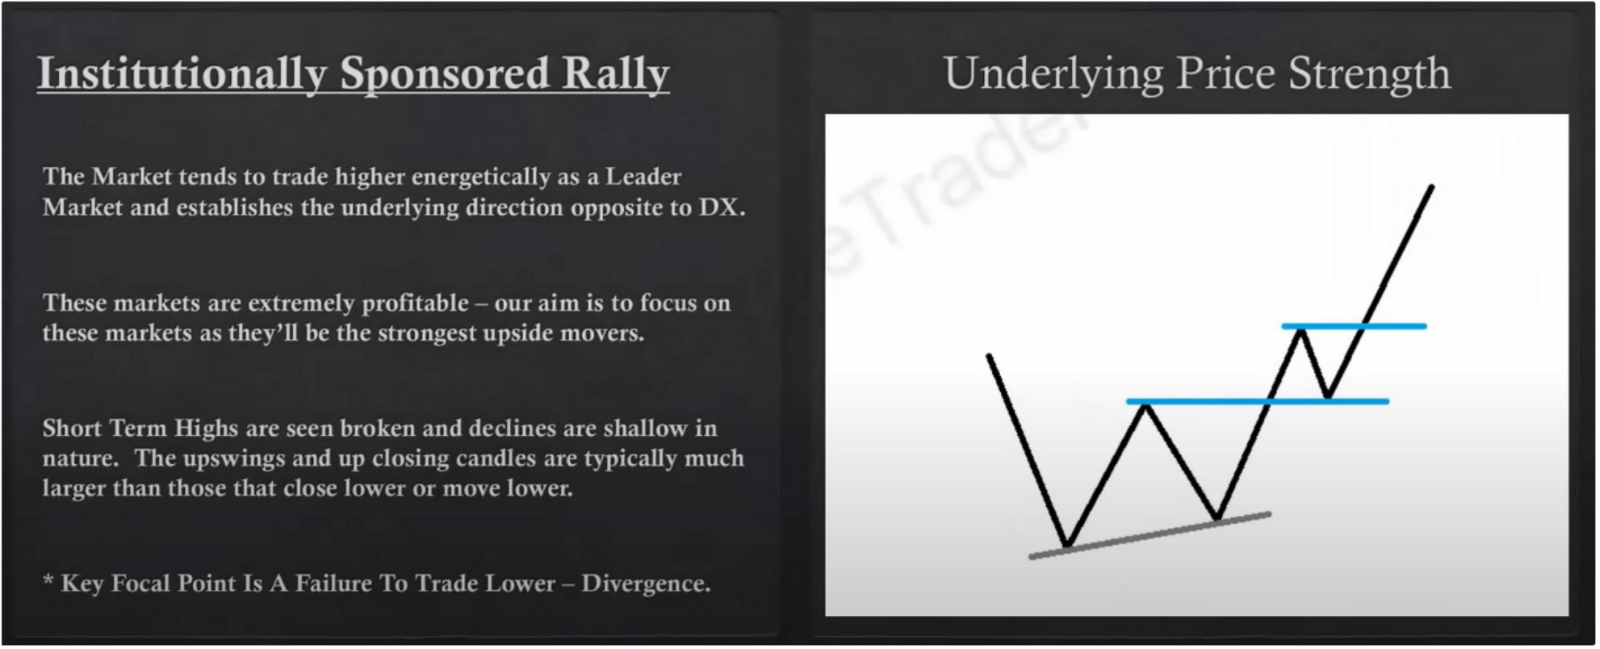

Relative strength analysis is basically factoring your analysis in the most important market to be following right now hen you're bullish and the most important market to be following when you're bearish and theres 2 simple ways of knowing what that is

Dollar index is like the king

If dollar is going higher thats going to put pressure on the commodity indexes Underlying price strength is what you clasically want to see when buying commodities

You have to look at what the dollar is doing as a whole tho, because just because theres 1 divergence doesnt mean theres a trade setup. You have to have your analysis on the dollar index

Not every commodity will rally, thats why we say relative strength analysis

We would look for the commodity that failed to make a lower low, because that commodity is stronger

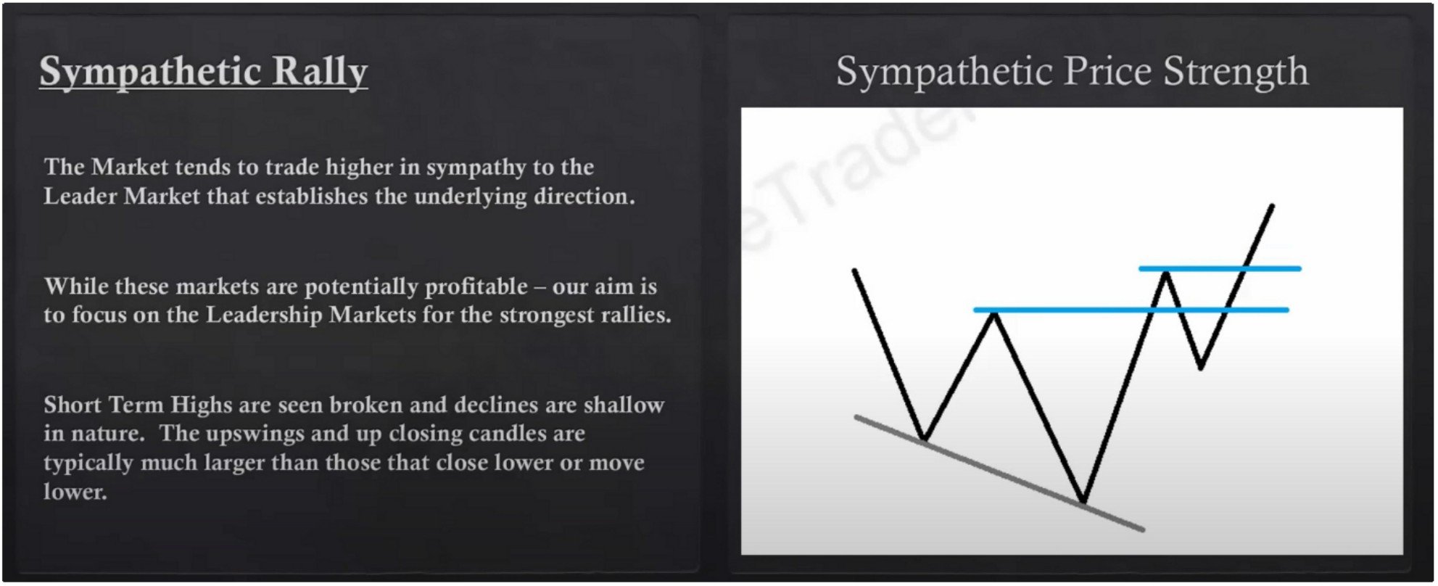

In this case youre not buying the relative strength leader, the sick sister of the group, its not as strong and efficient

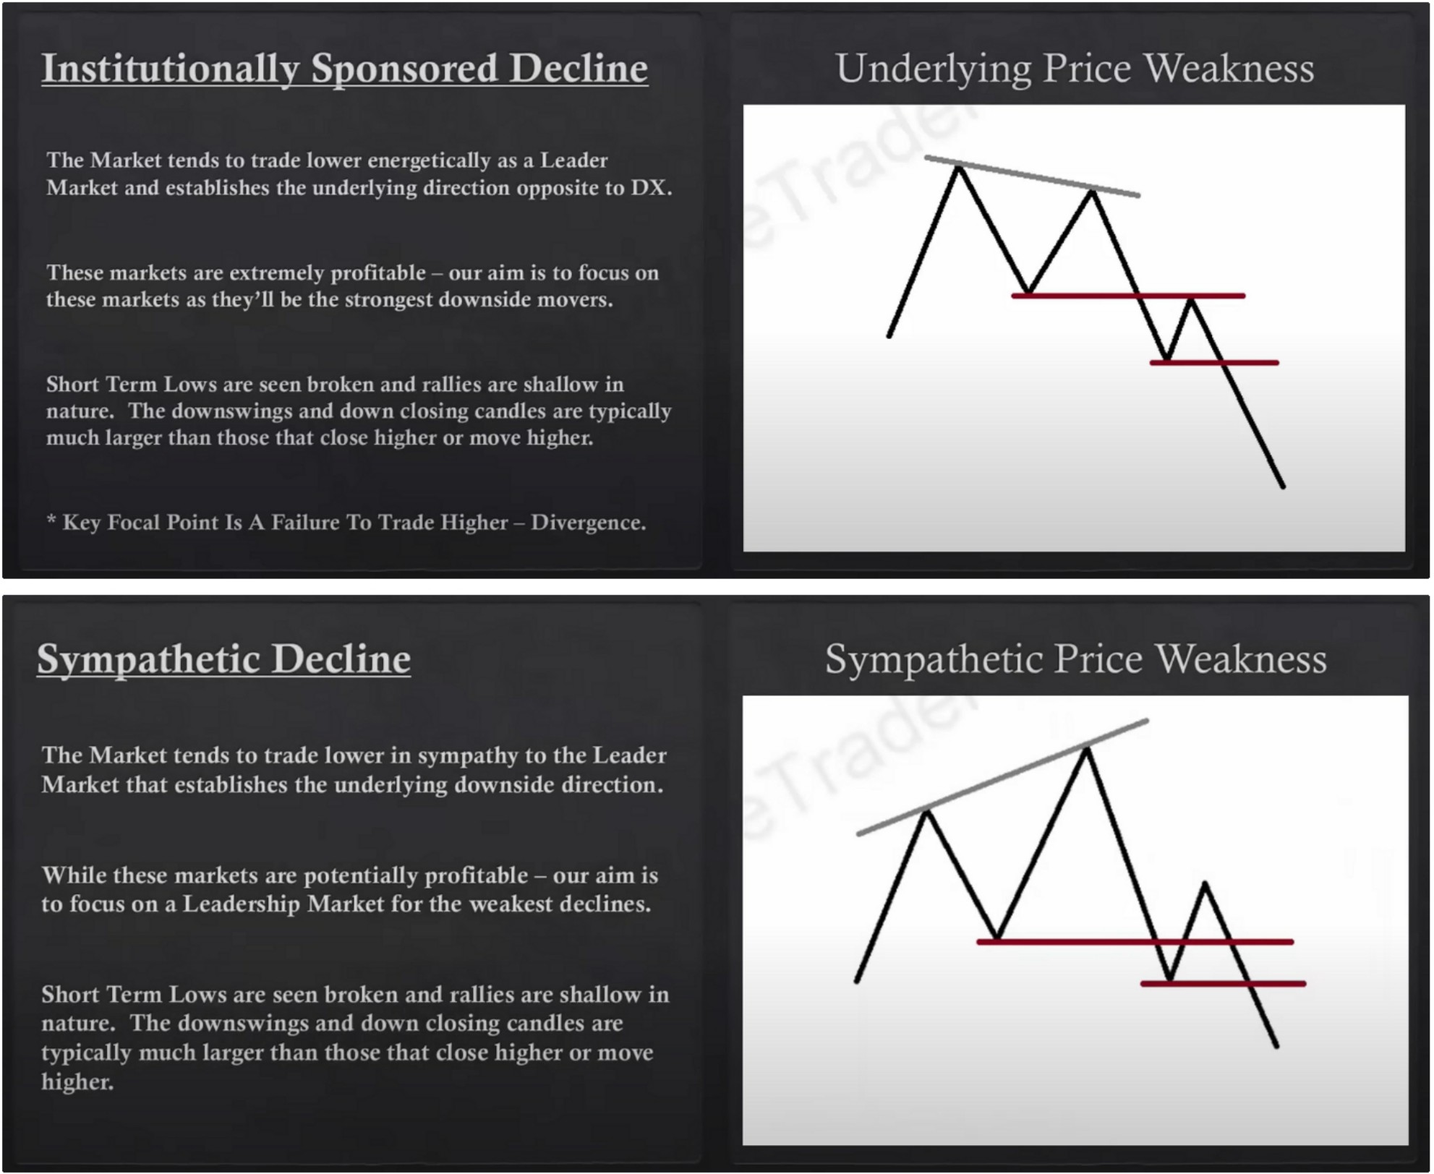

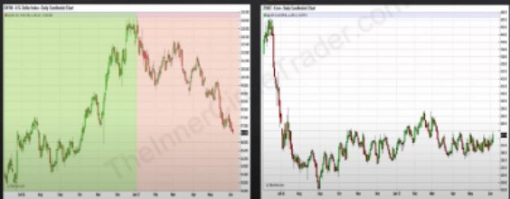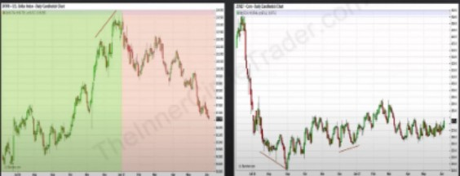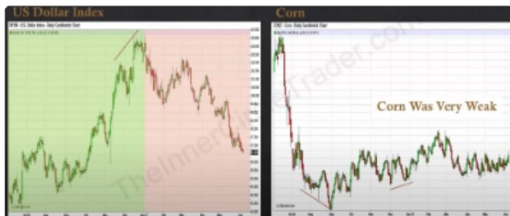

Corn showed no leadership buying

· ,"" """"""""

·1:1.0XI

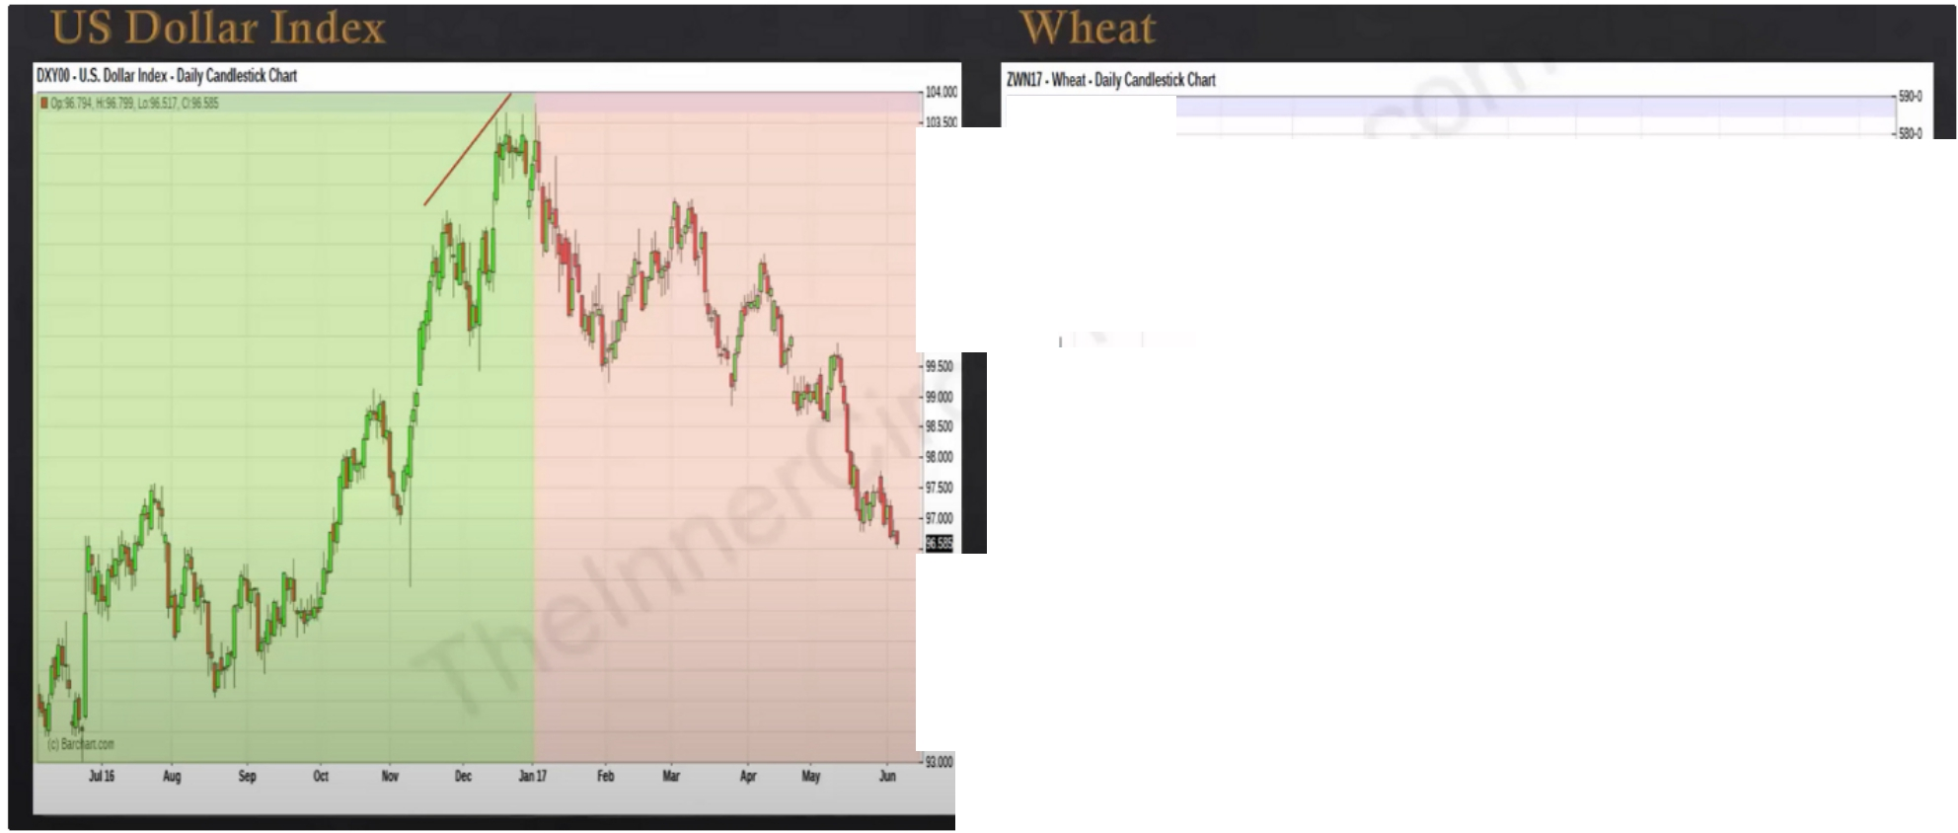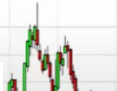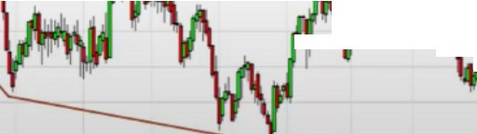

,,.,.

.

...,,

....

....

....

**at Was Very Weak** _..,

....

....

....

....

....

....

. •. · w

.,.,

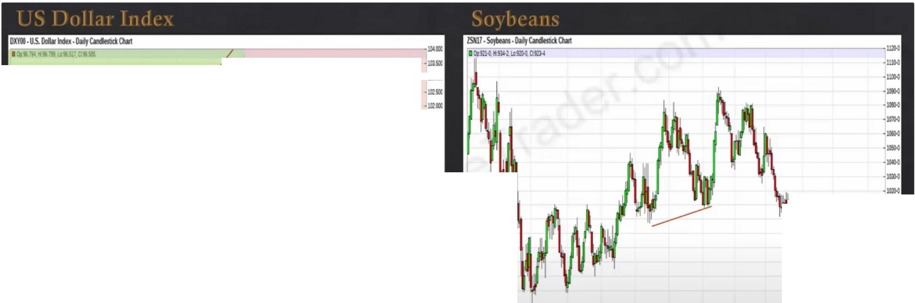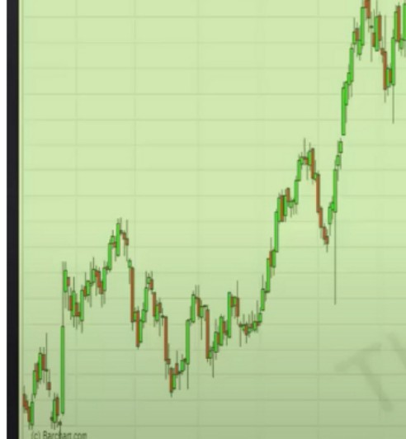

*f* \

_,.,,.,

111,i/ J. *\(* \

i *I*1 '

\

1t1J

:::

:::

:::

........

....

....

.**.**.**ll**.**l**.**l**

........

....

\·

\

I-

....

....

....

Jill. ...

Sit

Ocl

llr k

•11

19

1111

,,,,

la

·.'".".

**Soybeans Were Strong**

.■

-,

Soybeans was the leader of the grains

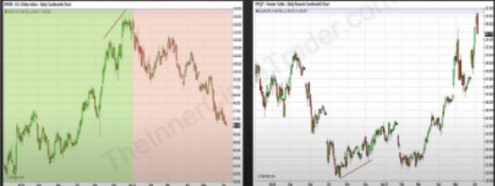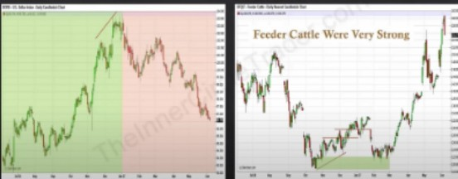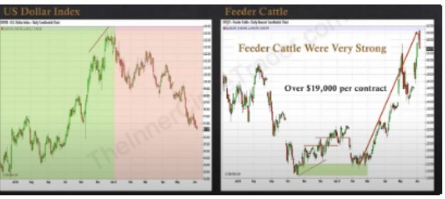

If price is not going lower it means theyre buying it and its under accumulation Blending PD arrays, institutional orderflow and divergence

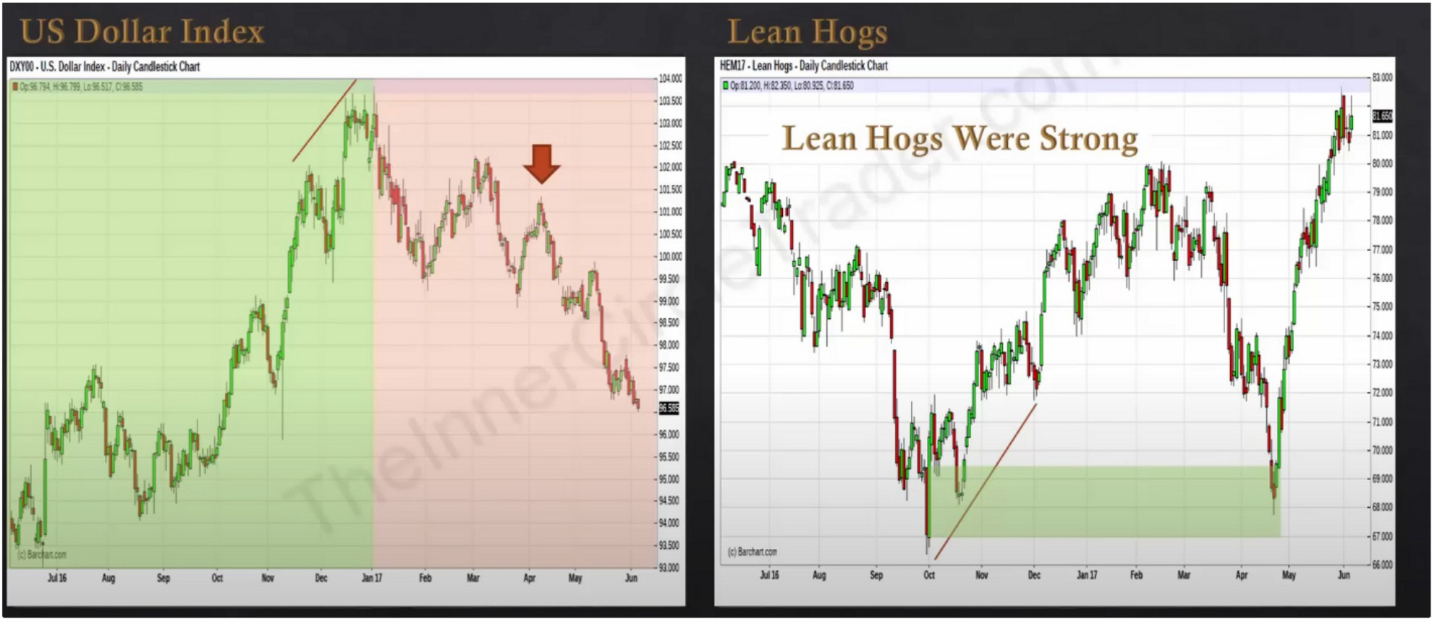

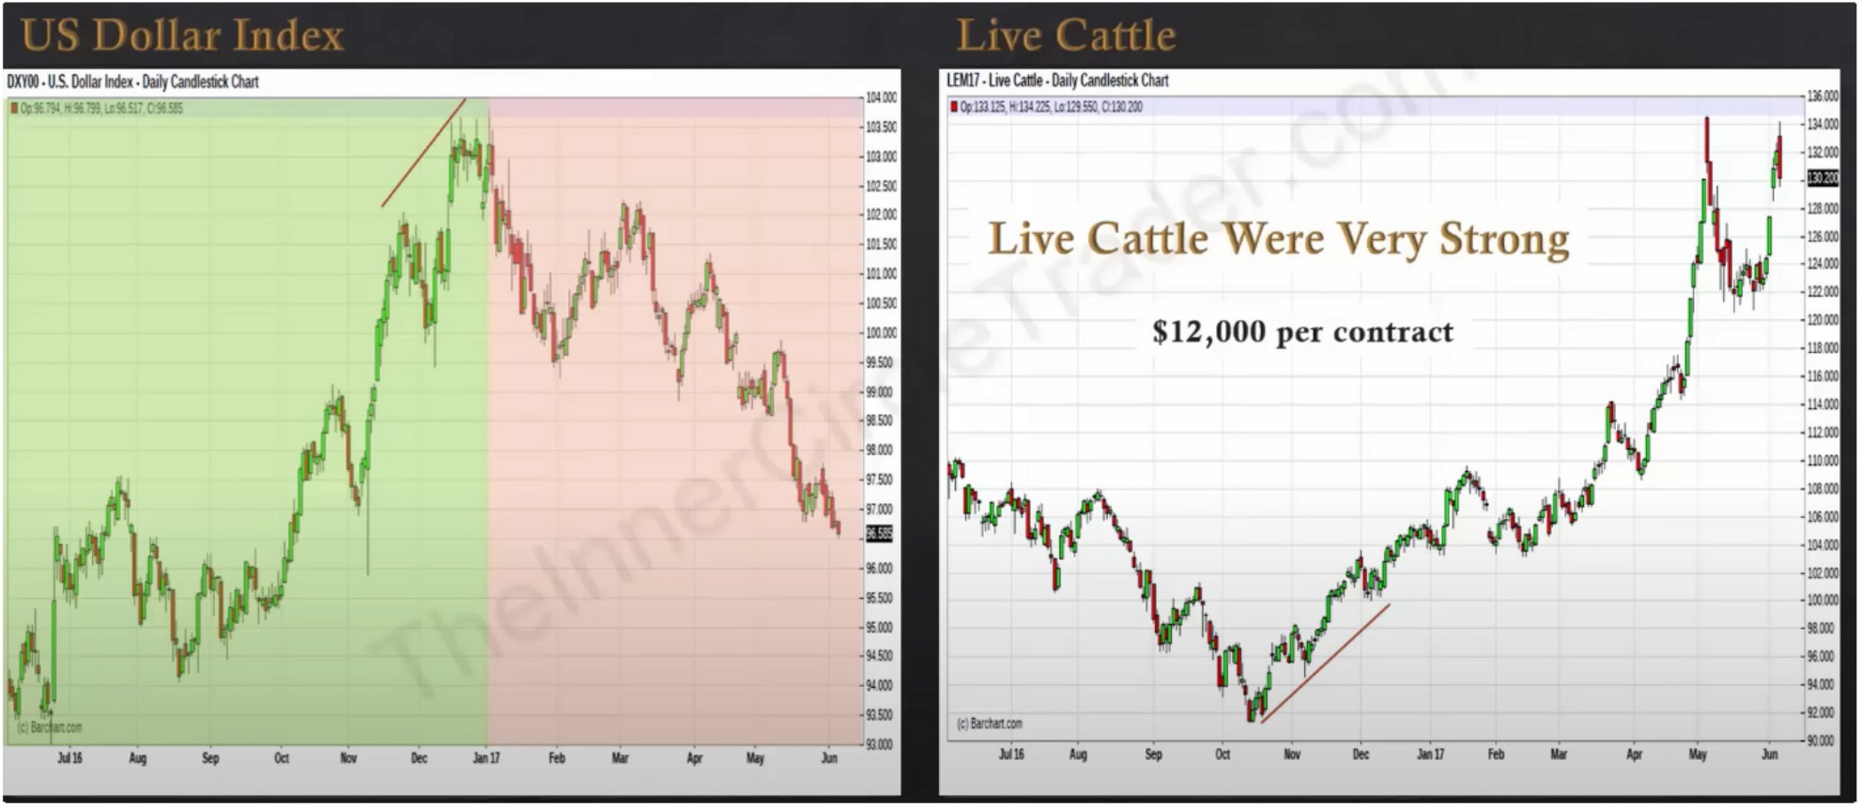

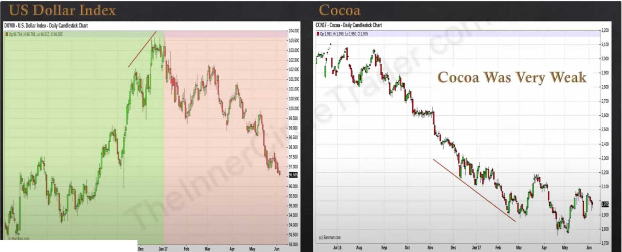

*M•*

...

Se,

OIi

..

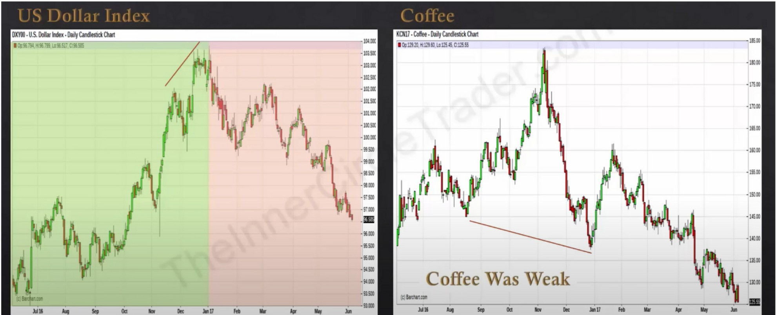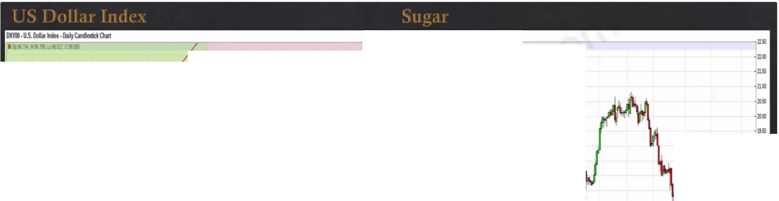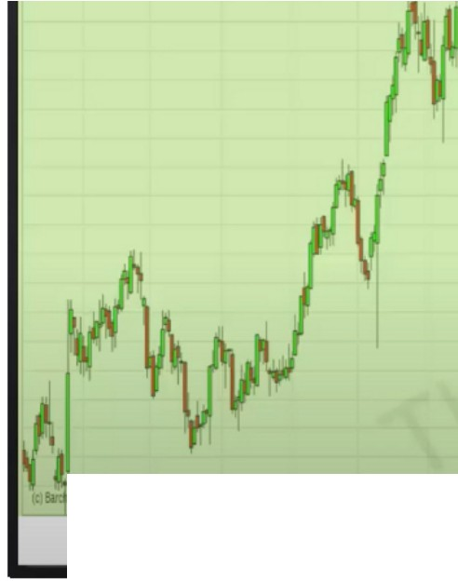

***r***

***·***

)11115 .. S.

OQ

- Dec au

fa

IIIIJ

*l,fl* 1i11r

-**·k,.**

.•,.

M n:m

**Sugar Was Weak**

:e-s

lllll AillJ

•​ ■

C

Se,

O:I

b

Ire lllD fff ...

..

-

lill lljJ

r,

:: ,w •ou•

**581111-Sog,,IU.Doly-°'"1**

·

**A**

·=

' • II

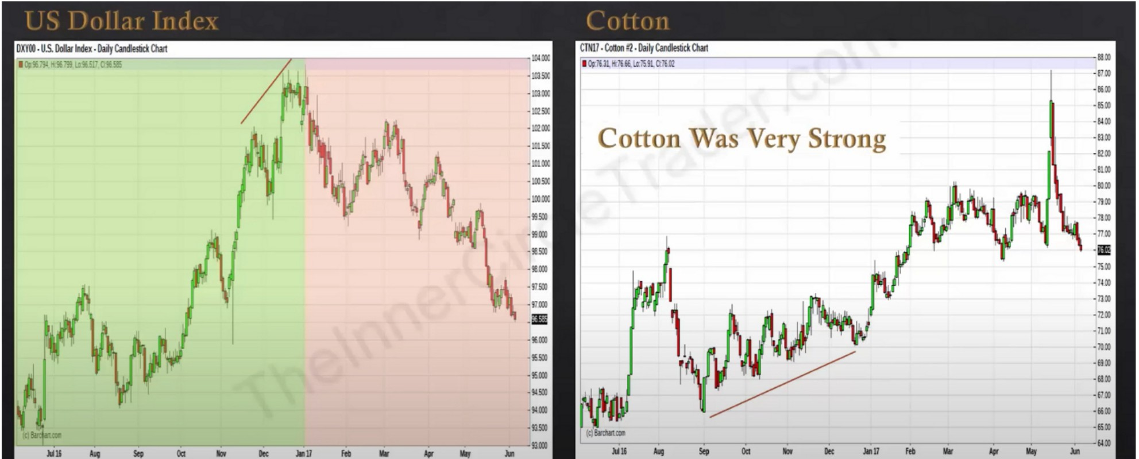

Financials now

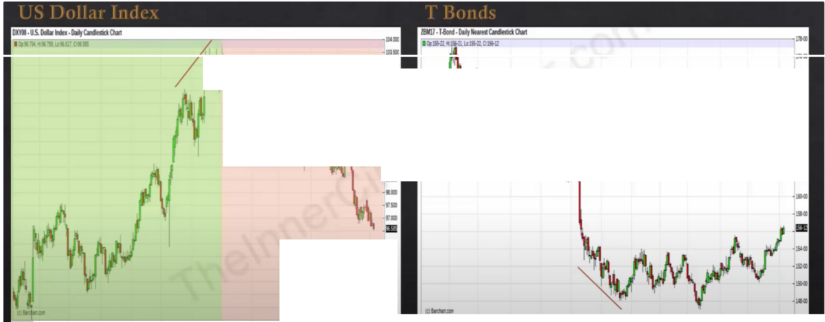

***'1!***

-

.,...

.·-.,..

·Ill"

.·".'.".

·""

*(*

'

**T Bonds Were Weak**

•""3

·-

·-

·-

.·.".'."

.,...,

....

.

·-

.....

........

.._..

........

,..,

**lillll All Sep oa b 111c lll11 f1'**

**.. *1ft* lfil' M**

**----•a**

**MIi Ml se, Otl b Die Jlllll fa** .. ... .., ..

Bond market has been range bound, so thats why forex at that time couldnt really provide a sustained move

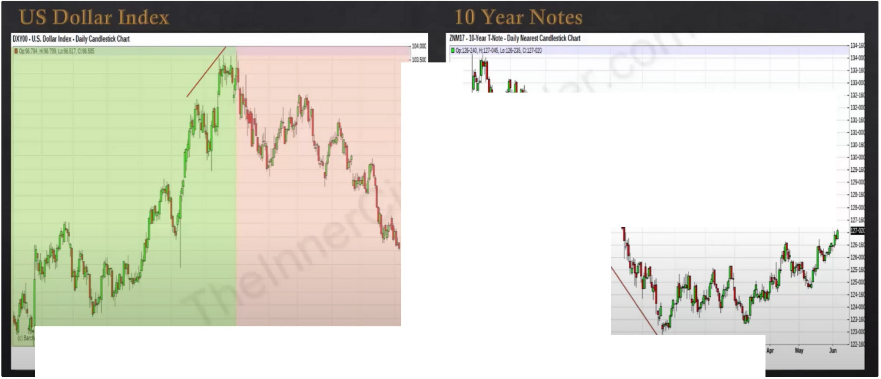

**•IOlO[**

·•.",".,' /\ ·' **M., lOYearNotesWereWeak**

.-...

::

**!i''fJ\ '** r

*(*

....

....

...Ill..

......

....

**MIi Alf 5tf O:! IIDf Ille llllJ f1' Mir** ,- - **la**

...

,..- -.. **Sefi Ila llf ltc lall fa llllr**

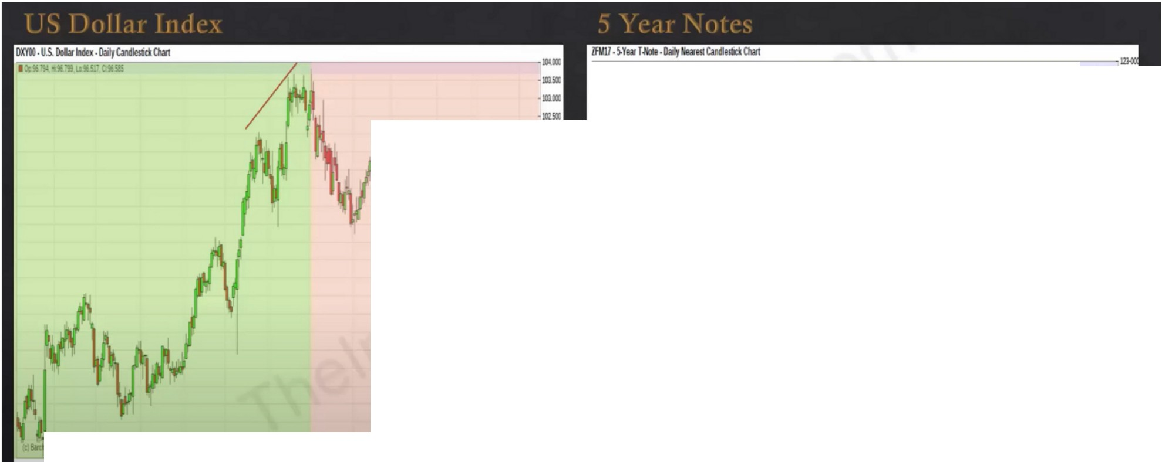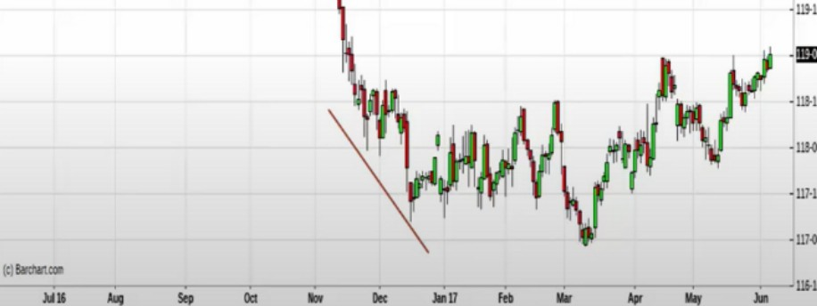

**10Jll&-Zl71tl1MD.\a:llt-Z!Scwt05**

**"'1**

***')i***

·\::.:...

....

,

:::

::

**A .** .. **SYearNotesWereWeak**

-m

...Ill..

....

.......

* **I.a**

**.ta Ml se, oa • Dec *au* ,. 1111' • 1111r** •

...

Interest rates are what move the markets

Note the divergence between the bonds as well, i think ICT will talk about that in the bond trading episodes

With interest rate differential

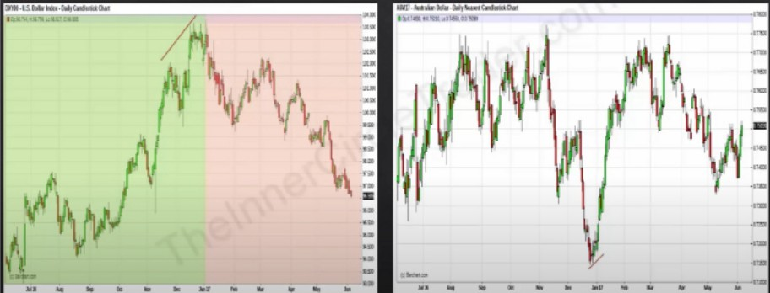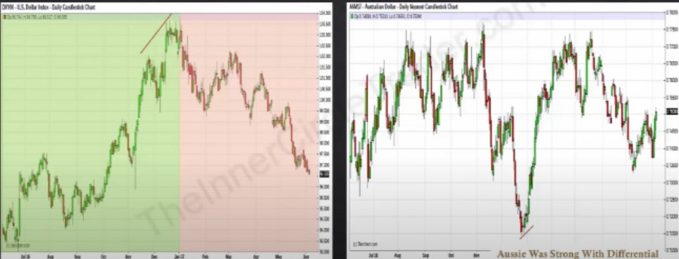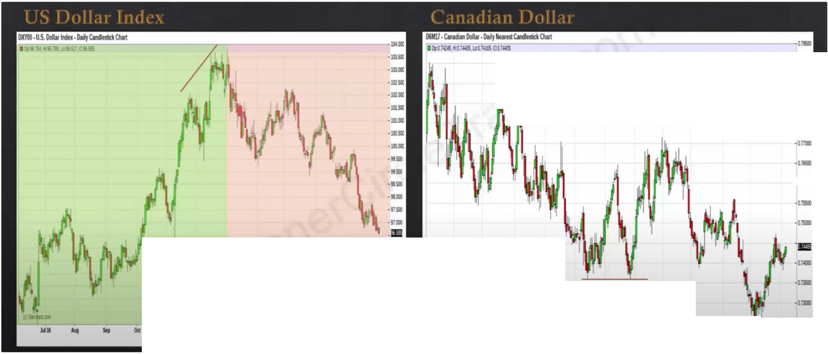

**Canadian Was Modestly Strong** ...,,...,..

I I .,..,

-Q.7151)

.....

•

....

....

-Ui:D **(C·!ar.:lna.**

**Dlil: 11111** ,. . . **.-;--ua** ----:-:::-,.. ----,-.,--:-., -.,:----:-., -,.:-:-::,..-,,.,,-------,-,.-•: ::-1-• ,,,,.

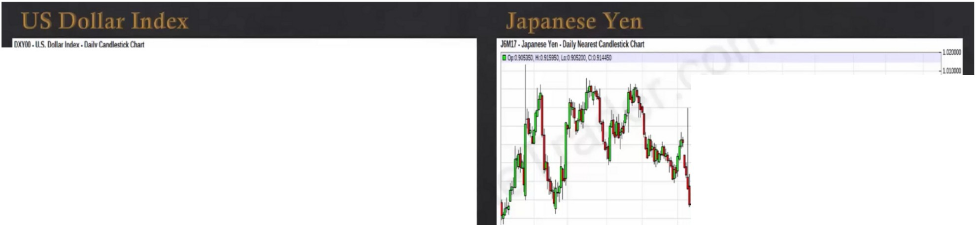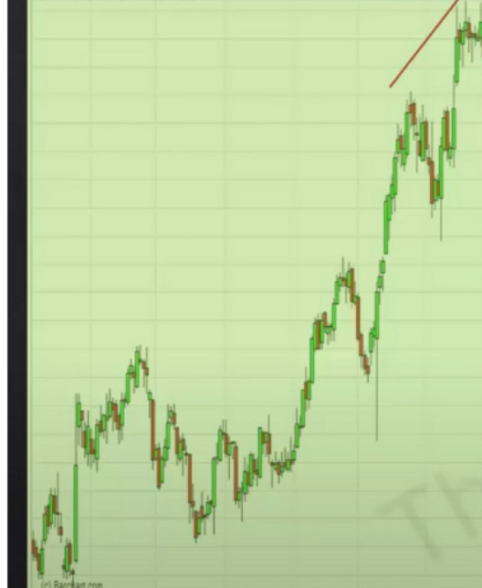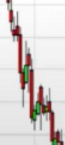

* ...----------,- --- "'"

·10:UX

*\*'

*t r*

·1'1.CIX

·l-

·O.!lml

.,,.,.,

**Yen Was Very Strong::**

-•-

--,um

**Jill» ,.. s., oa** .,,, ._ **au** ,. ... ,. ..,

•

-mm

""

tcsn.tc.

**M**■ **.q**

,,

**1;11"1**

**St!I oa**--**b 111**-**c** -**11111** ,**flt Mir ,_**• **111r**

•

-0..mm

**o.sm**

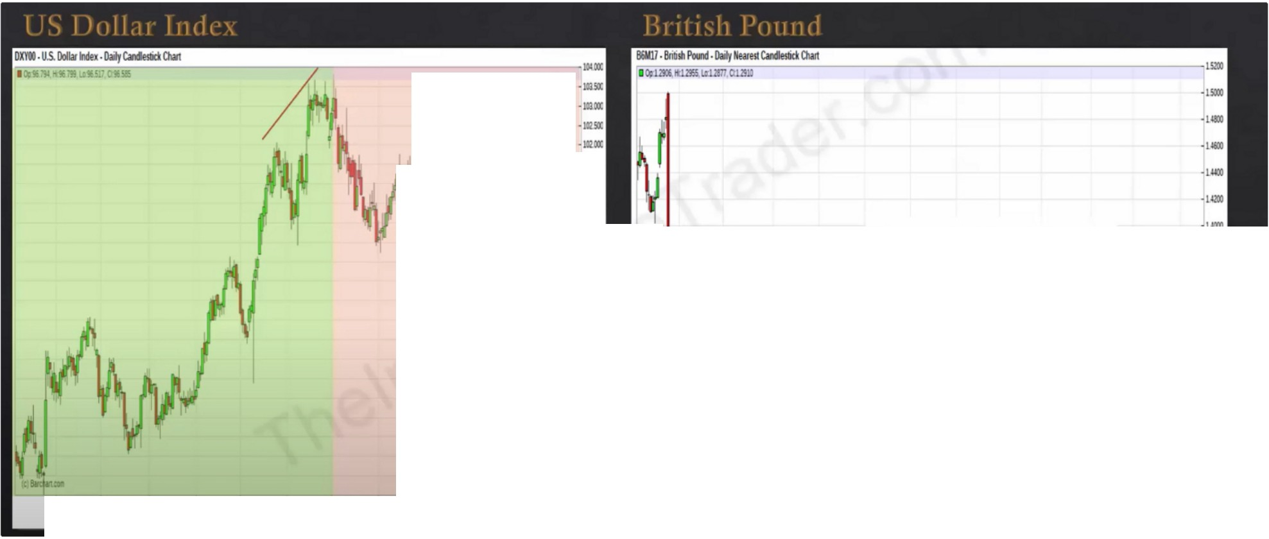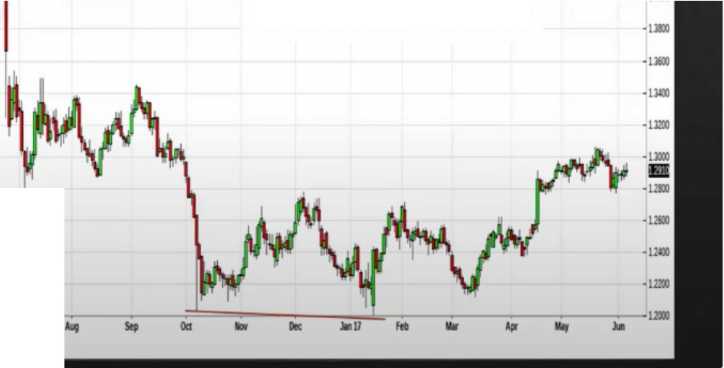

*t* llr\

Mt

· \:::......

::

.....

**Pound Was Weak**

....

....,...

**lll**

....

....

.,.

,,._,.

MIi .1111J - OCI

..

Ille 11111 *1"* .. *1ft* ¥Ir lil,

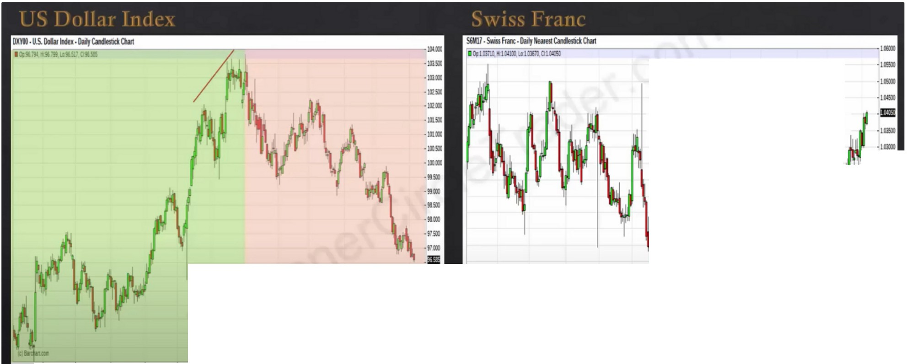

**Francs Were Strong**

.,...

I

I

a I

1 •.

.,...

.,...

-um

* l01lll)

......

*i*

I

·.•..-..

.,...

....

I

.,

.

..

MU ""1 St, OIi b

DIC llll1 hfl; 11W . ..

,. .,.

.**·K**.**D**..

. ,

-Ofl!LO

..

'""

.. ..

•

..

,. ....

.....

AUD, yen, and franc as our leadership markets of the currencies so far

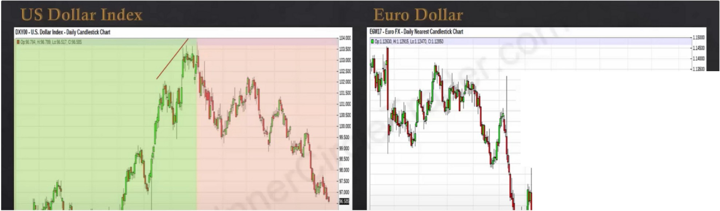

**Euro Was Strong**

·-

*f*

·"""

·Ullll

•I.IJSall

**.w,oo**

·.',-",",.,

' I

Ai §

Also leadership

Interest rate differential with aussy, because people in aussy need to pay the interest rate differential for holding kiwi or something like that

Metals

Energy complex

We looked at the leaders, not everyone move higher when dollar move lower, so we looked at the leaders. Discount arrays were holding short term highs were failing etc

Focus on the ones that give you the clearest signs of distribution and accumulation